AI ASSISTED CODING
LAB-4
YASHASWINI
2303A51764
BATCH-12
Task Description #1 (Privacy in API Usage)
Task: Use an AI tool to generate a Python program that connects to a weather API.
Prompt:
"Generate code to fetch weather data securely without exposing API keys in the code."
Expected Output:
- Original AI code (check if keys are hardcoded).
- Secure version using environment variables.
PROMPT:
#Generate a Python program that fetches weather data from a public weather API.Do NOT hardcode the API key anywhere in the source code.The API key MUST be read only from an environment variable using the os module.If the API key is missing,the program should raise an error.Do not include placeholder API keys in the code.
CODE:
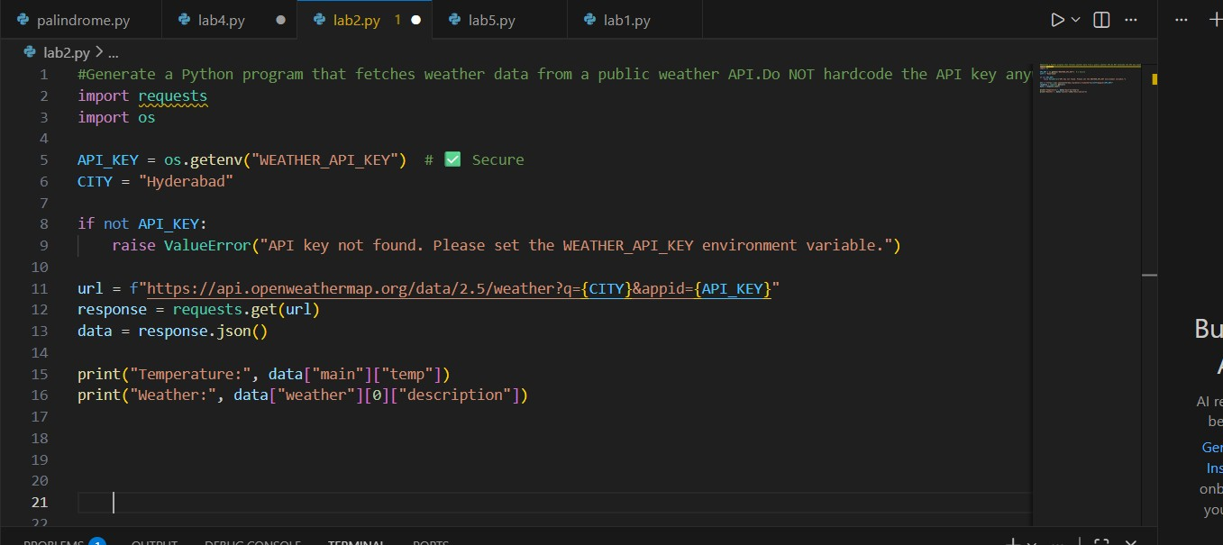

Task Description #2 (Privacy & Security in File Handling)
Task: Use an AI tool to generate a Python script that stores user data
(name, email, password) in a file.
Analyze: Check if the AI stores sensitive data in plain text or without encryption.
Expected Output:
- Identified privacy risks.
- Revised version with encrypted password storage (e.g., hashing).
PROMPT:
#Write a program that securely stores user credentials by hashing the password and ensuring sensitive data is not stored in plain text.
CODE:
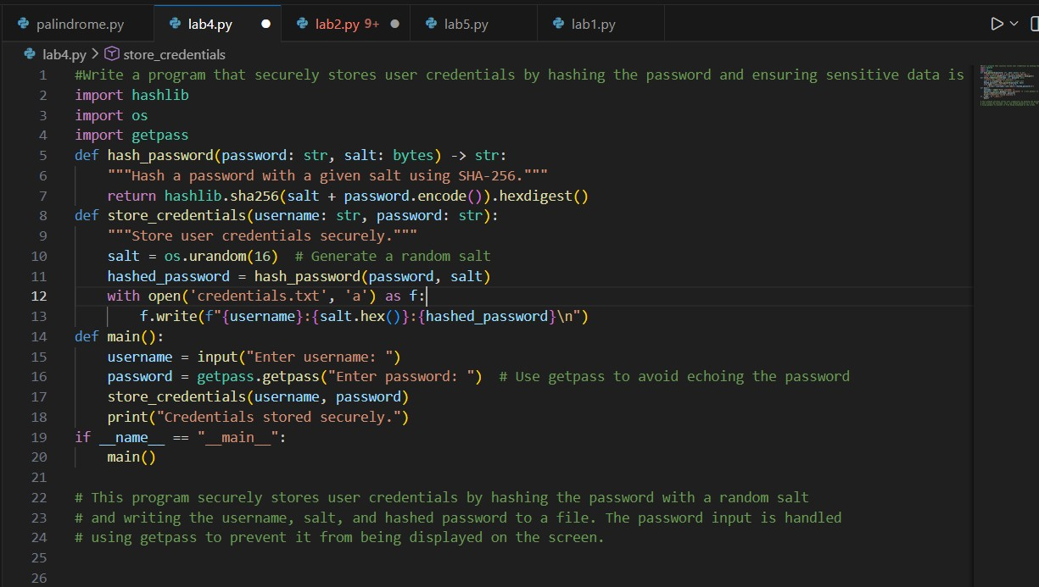
OUTPUT:
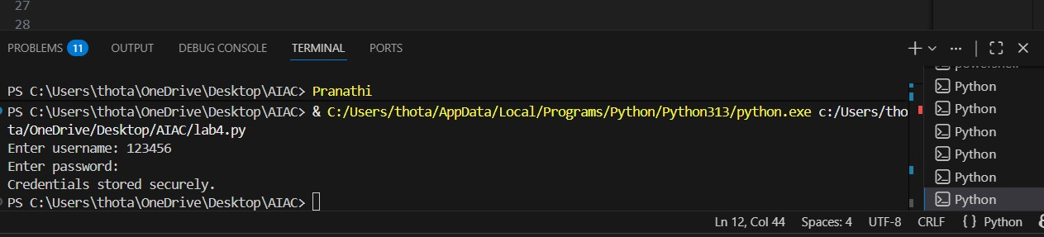
Task Description #3 (Transparency in Algorithm Design) Objective: Use AI to generate an Armstrong number checking function with comments and explanations.
Instructions:
- Ask AI to explain the code line-by-line.
- Compare the explanation with code functionality.
Expected Output:
- Transparent, commented code.
- Correct, easy-to-understand explanation PROMPT:
#write a code to generate armstrong number checking functions with comments CODE:
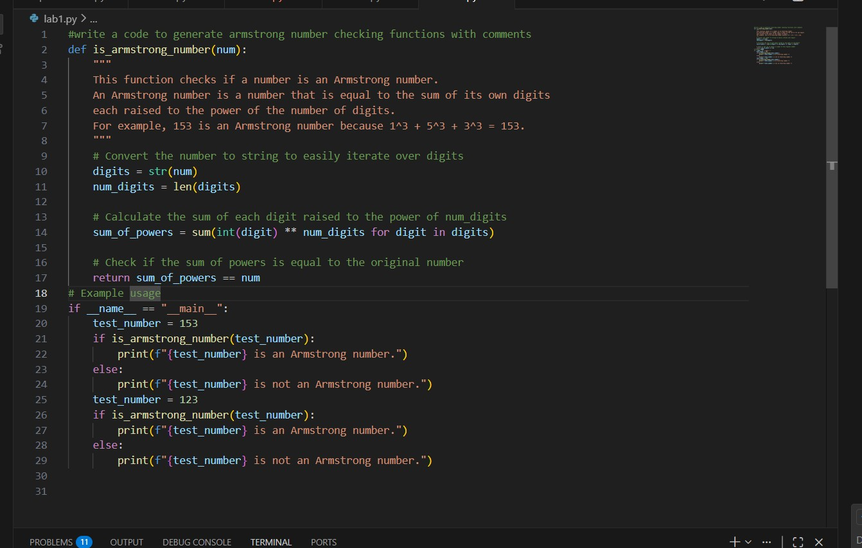
OUTPUT:
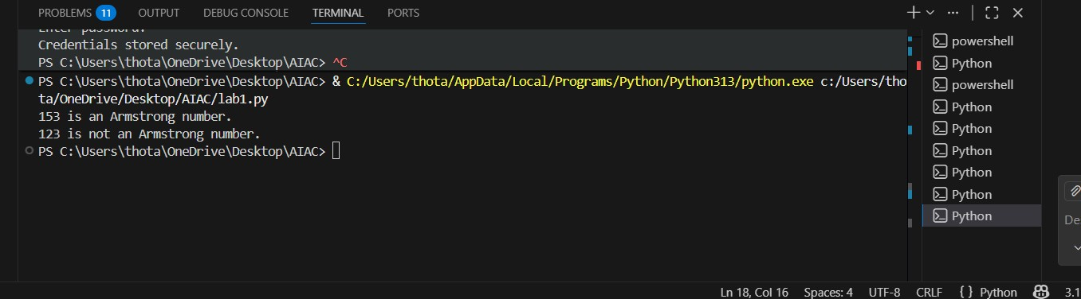
Task Description #4 (Transparency in Algorithm Comparison)
Task: Use AI to implement two sorting algorithms (e.g., QuickSort and BubbleSort).
Prompt:
"Generate Python code for QuickSort and BubbleSort, and include comments explaining step-by-step how each works and where they differ." Expected Output:
- Code for both algorithms.
- Transparent, comparative explanation of their logic and efficiency.
PROMPT:
#Generate Python code for QuickSort and BubbleSort, and include comments explaining step-by-step how each works and where they differ.
CODE:
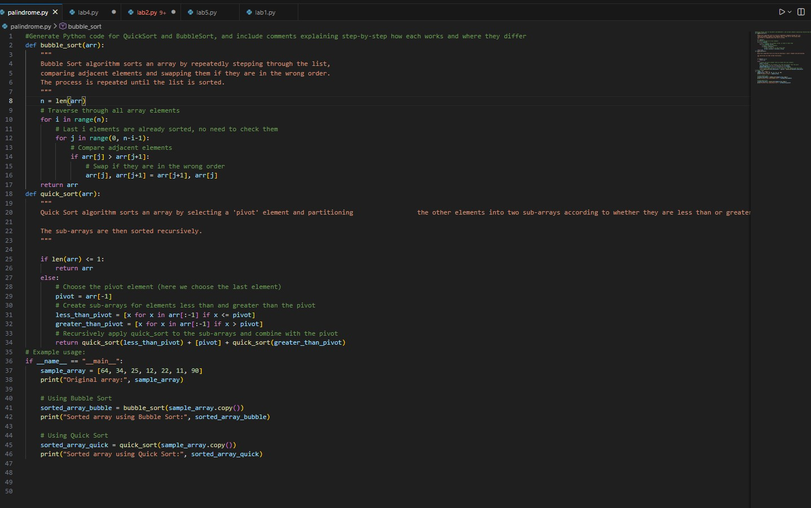
OUTPUT:
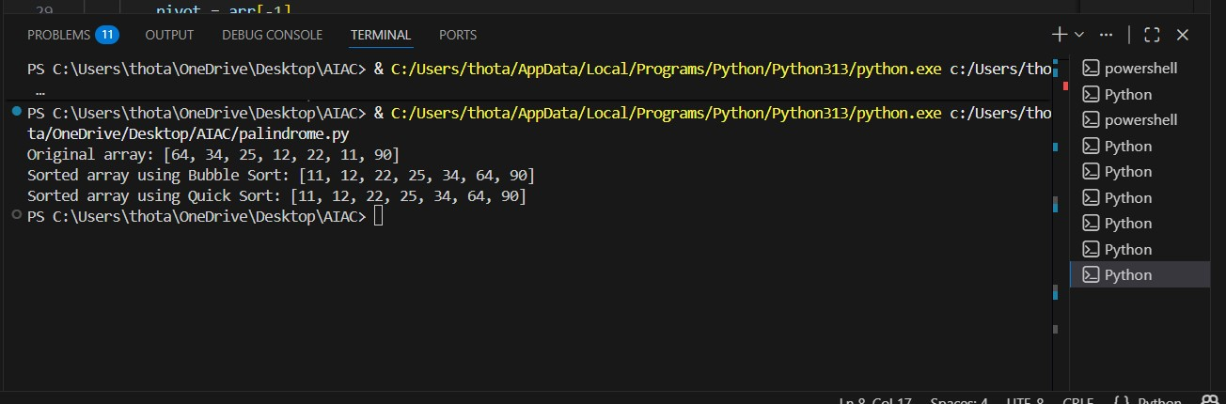
Task Description #5 (Transparency in AI Recommendations)
Task: Use AI to create a product recommendation system.
Prompt:
"Generate a recommendation system that also provides reasons for each suggestion."
Expected Output:
- Code with explainable recommendations.
- Evaluation of whether explanations are understandable.
PROMPT:
#Generate a recommendation system that also provides reasons for each suggestion." CODE:
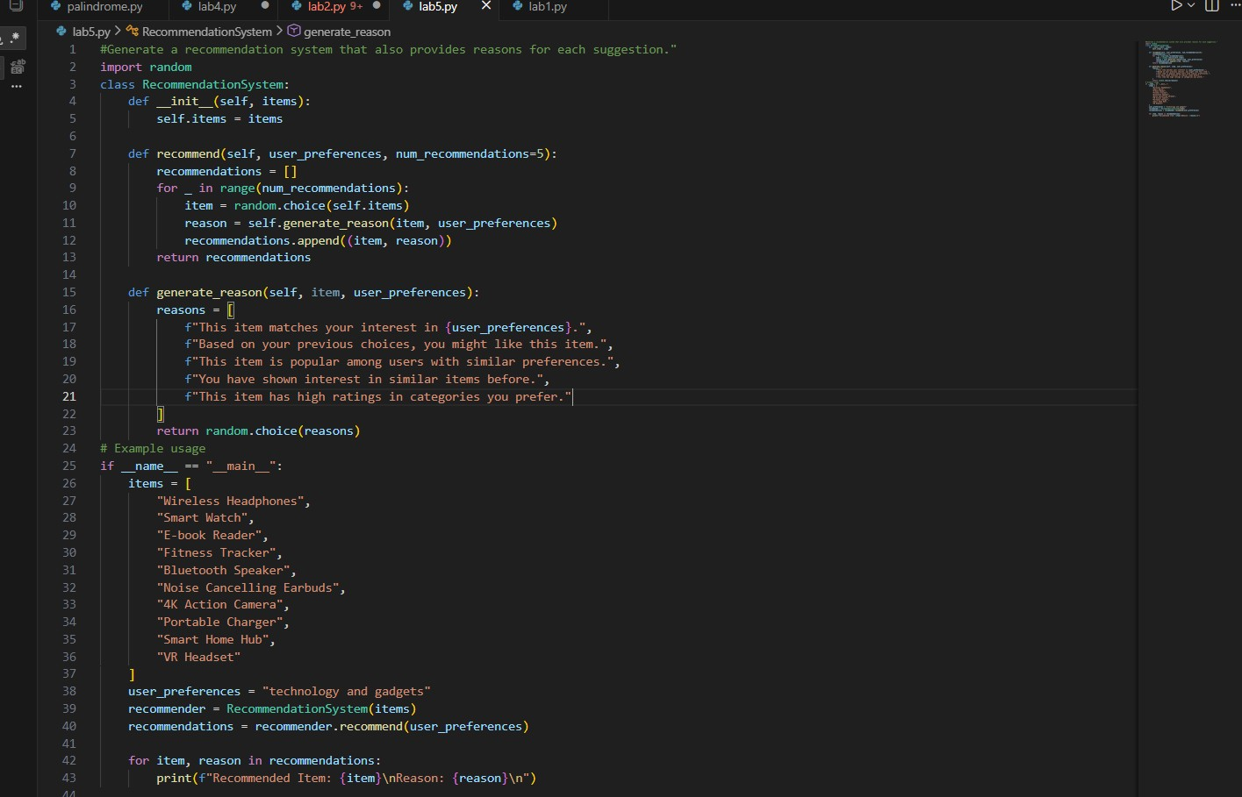
OUTPUT:
